**Figure S1.** Illustrative example of design of SC input with overlapping frequencies. Red lines are event times, black dotted line is where the frequency changes. Experimental recordings in our Lab showed that SC input frequency varied between 16 and 32 Hz. Also, two frequency components were noted in the experimental data over a typical duration of 1000 ms (shown above): a steady one that continued over the entire duration, and a second one that lasted for 600 ms, starting from 300 ms and ending at 900 ms. The steady component in the plot above is at 15 Hz, and a faster component (at 32 Hz in plot above) that causes spiking in SIZ. We refer to this faster component as the “intra-burst frequency” or just “frequency”. Since this is a forced burster, the burst ends after 1000 ms in experimental data (and in our model), and so we consider 1000 ms as the burst duration. The inter-burst interval is not relevant for this study.

**S2A**  **S2B**

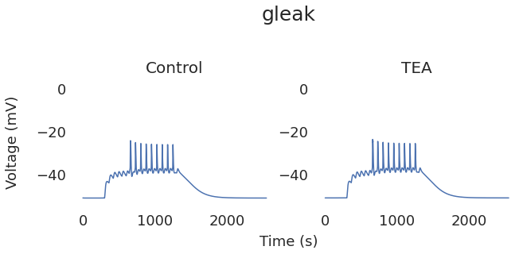 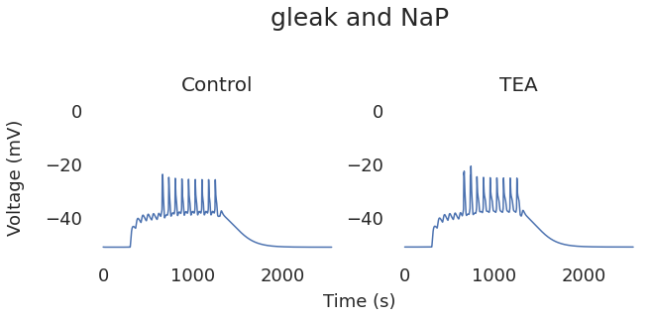

**S2C S2D**

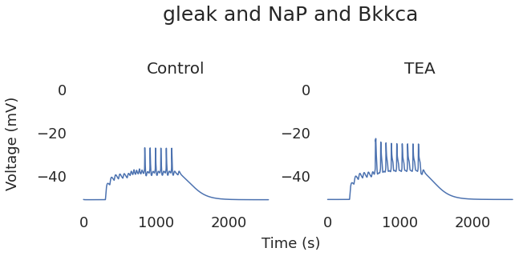 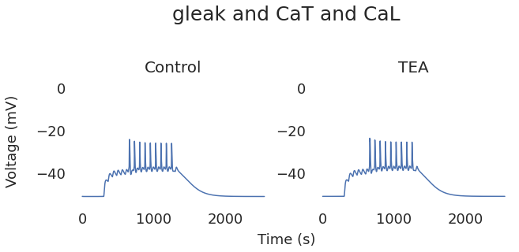

**S2E S2F**

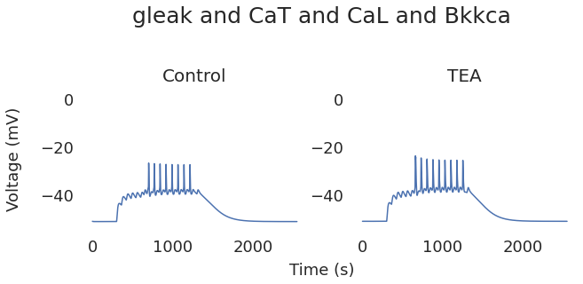 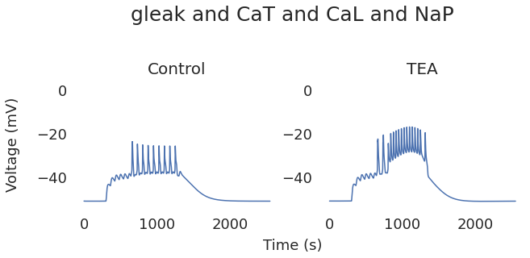

**S2G S2H**

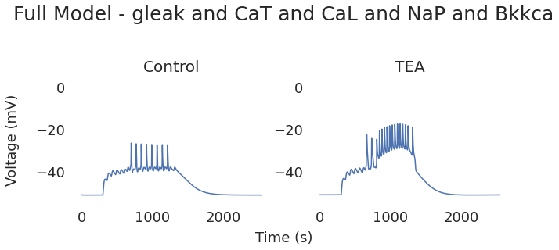 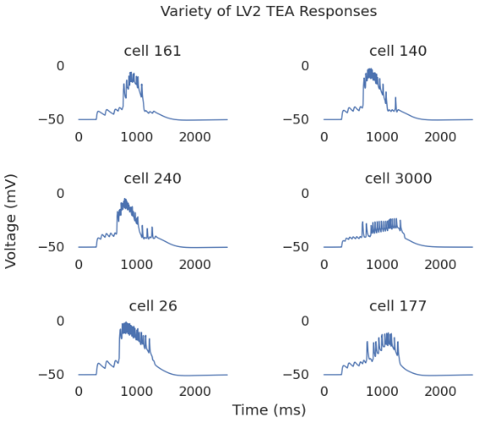

Figure S2. **Procedure to select active channels for the neurite compartment in the intact cell**. **A-F:**

**A:** When all active conductances are removed in the neurite there is no TEA response. **B:** The addition of NaP to the neurite can produce very similar TEA responses, but with LC spike frequency and height that is unrealistically high for control cases. In the 16-32 Hz range, fig. 1A is a common response. Since cells are already close to being too excitable in the control case, the addition of NaP to the neurite makes them unrealistically excitable. **C:** Adding BKKCa reduces the excitability of the cell, opposing the effects of Nap, but without calcium channels the reduction is too small. **D:** CaS and CaT were also tried as alternatives to NaP that may carry the depolarization to the neurite for the TEA response, but the highest conductances within biological range still would not facilitate this response. **E:** Since the TEA response is a large depolarization, it is readily thinkable that calcium channels are instead responsible for the TEA response. However, with CaT, CaS, and BKKCa in the neurite, but no NaP, there is not a noticable TEA response. **F:** Calcium and NaP elicit an appropriate response but like (B) the control case is too excitable. **G:** The addition of channels which reduce NaP’s influence in the control case but allow it to facilitate the TEA response would be a reasonable addition. To that end, BKKCa, together with the calcium channels were added to find an acceptable combination. **H:** Variety of Network responses from passing networks in the full model. Each trace contains the Post TEA response of a different cell in a different network.

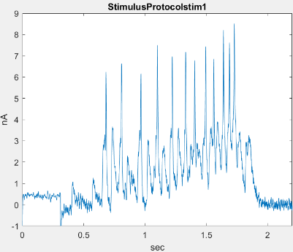 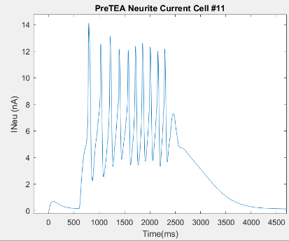

Figure S3A FigureS3B

**Figure S3.** Model neurite current resembles experimental stimulus protocol current. **A:** Experimental stimulus protocol current used in Ransdell et al. (2013). **B:** Model current from neurite to soma in control.